# FUN ONE

AUGUST 17-18, 2024

# Watkins Glen International 2790 County Rd. 16 Watkins Glen, NY 14891

## SUPPLEMENTAL REGULATIONS

##### This event is held under the 2024 SCCA General Competition Rules, amendments as published in 2024 “FastTrack, the SCCA Vintage GCR and these Supplemental Regulations.

**Sanction** 24-R-61846

**Vintage Sanction** 62688

***The SCCA strives to ensure that ALL participants in its events and activities enjoy a welcoming environment. The SCCA supports equality of opportunity and treatment for all participants and will make every effort to maintain an environment that is free of harassment, discrimination, and any behavior that interferes with a safe, fun, and exciting experience. A commitment to a welcoming environment and the SCCA Values is expected of all its members and attendees, including drivers, workers, crew, guests, staff, contractors and exhibitors, and other participants at SCCA activities, sessions and social events and when representing the SCCA in print or electronic media.***

***SCHEDULE:***

**Test Day: Friday, August 16**- WGI-operated Test Day. Details are on the WGI Test Day flier, which follows these Supps. Test day registration is ONLY at the track, on Thursday August 15th and during registration Friday August 16th. There is no pre-registration for the Test Day, and competitors SHOULD NOT call Watkins Glen for details of that test day. Refer to the Test Day flier. Test Day payment is by cash or credit card ONLY. This is not an SCCA-sanctioned test day.

## RACE GROUPS

**Group 1:** FA, FC, FE, FE2, ASR, P1, P2, FS, FX, SRFx* **Group 2:** SM, SSM, SMT, SM2, C-SPEC, IT7, SMX **Group 3:** HRG1, HRG2, HRG3, HRG4, HRG5

**Group 4:** SRF, SRF3

**Group 5:** FF, CF, CFC, FV, FVR, F6 (F600), FST, Challenge Cup**

**Group 6:** GT1, GT2, GT3, AS, ITE, GTA, T1, T2, SPO, GTX, Spec Corvette, ITS, ITR, STU

**Group 7:** EP,FP,HP,GTL,STL,SPU,T3,ITA,ITB,ITC,B-SPEC,T4,IT-EZ

Rules for HRG classes can be found at [www.SCCA.com](http://www.SCCA.com/) under Road Race Rules in the Vintage GCR

Rules for NeDiv regional classes can be found at [http://www.nediv.com](http://www.nediv.com/)

*Must be registered in SRF or SRF3. SRFx is a regional class from NER to allow double dipping for SRF and SRF3

** Challenge Cup rules listed on [www.flr-scca.com/club-racing](http://www.flr-scca.com/club-racing)

**NEDIV Divisional race awards will be presented in the tech area after each Regional race on both days**

### Fun One Schedule

|  |  |
| --- | --- |
| **Thursday August 15, 2024** | |
| **6:00 PM – 9:00 PM** | **Registration open for SCCA Race/Worker entrants** |
|  | Express Tech will be open at registration. Bring helmet with 2024 sticker and logbook. |
| **6:00 PM – 8:00 PM** | WGI test day registration. |
| **6:30 PM – 9:00 PM** | Tech open in Garage. Bring Helmet with 2024 sticker & logbook |
|  |  |
| **Friday August 16, 2024** | |
| **6:00 AM – 10:00 AM** | Registration open for WGI Test Day and SCCA. Express Tech open at registration Bring helmet with 2024 sticker and logbook |
|  |  |
| **4:00 PM – 9:00 PM** | Registration open for Race / Workers entrants. Express Tech open at Registration, bring helmet with 2024 sticker & logbook. |
| **3:00 PM – 9:00 PM** | Tech inspection opens in Garage. Bring helmet with 2024 sticker & logbook. |
| **Saturday August 17, 2024** | |
| **7:00 – 10:00 AM** | Registration open |
| **7:30 – 10:00 AM** | Tech inspection opens in Garage. Bring Helmet with 2024 sticker & logbook |
| **Hours TBA** | Scales open in Garage. |
| **8:30 AM** | Regional Qualifying (Groups 1 – 7) – 20 minutes by group. Drivers meeting after each session. |
| **Followed by** | Regional Races (Groups 1 - 7) 25 minutes. |
| **12:00 – 1:00 PM** | Lunch. (Approximate time) |
| **After lunch** | Regional Races continue |
| **Due to rising cost and lower than normal participation we will not be hosting an after race party on Saturday.** | |
|  | |
| **Sunday August 18, 2024** | |
| **7:30 – 9:30** | Registration open. |
| **7:30 - 10:00 AM** | Tech open in garage Bring helmet with 2024 sticker and logbook |
| **Hours TBA** | Scales open in Garage. |
| **8:30 AM** | Regional Qualifying (Groups 1 – 7) – 20 minutes by group. |
| **Followed by** | Regional Races (Groups 1 – 7) 25 minutes. |
| **12:00 – 1:00 PM** | Lunch. (Approximate time) |
| **After lunch** | Regional Races continue |

**NEDIV Divisional race awards will be presented in the tech area after each Regional race both days. ALL QUALIFYING AND RACE TIMES ARE APPROXIMATE.**

#### SATURDAY REGIONAL RACES ARE ON THE 3.4 MILE LONG COURSE. SUNDAY REGIONAL RACES ARE ON THE 2.4 MILE SHORT COURSE.

**REGISTRATION** is available online at  [http://msreg.com/FLRFunOne24.](http://www.motorsportsreg.com/)

Entry information is available from registrar: Marsha Toombs, 152 Gillette St. Rochester, NY 14619-2227 [metoombs@netacc.net.](mailto:metoombs@netacc.net) (585)746-5004.

**CREDENTIALS** will be provided for driver, entrant, and up to four crew members at registration. A signed waiver or SCCA annual waiver is required to receive a credential. Credentials are required to gain access to the track and must be worn at all times. Driver or entrant must provide the names of each person receiving a credential and those authorized to purchase over crew passes. Proof of age and identity is required.

**DRIVER ELIGIBILITY:** Races are open to all current SCCA Full Competition, Pro license, and novice permit holders as per GCR3.1.2.A. and GCR Appendix C 2.8.B. Per WGI rules no drivers are allowed under the age of 18. All crew in the hot pits must be SCCA members. Temporary memberships are available at registration.

**Number assignments:** Competition numbers of up to three digits will be assigned upon acceptance of an entry (three –digit numbers only permitted with a leading 1, ex: 128. The registrar reserves the right to assign numbers to avoid duplication within a race group and will NOT issue numbers until a valid application is received.

#### ENTRY FEES AND PAYMENT:

Weekend Entry - 2 days - $595.00 per car. Includes 4 person crew. Single Day Entry - 1 day - $425.00 per car. Includes 4 person crew. Double Dip (Same driver, same car, different class) - $375.00.

Over crew - $10.00 per person.

Race compliance fees for SRF, SRF3, FE, and FE2 - $30.00. Late fee (after 9/14) - $25.00.

GARAGE RENTAL: Garage Rental fee is $100. Garage requests are to be made through MotorsportReg when registering for the event. Be sure to include notes of parking preferences or garage bay requests - please also notify us if you have a large hauler, as not all garage parking spaces can accommodate the extended length! All special requests will be accommodated to the best of our ability. **Garage Rental fee is nonrefundable unless the garage is reassigned by the Registrar.**

Credit cards accepted online or at the track.

Finger Lakes Region prefers payment be made at the track, either by check, cash or credit card. Motorsportreg.com will have a "pay at the track" option.

Checks returned for insufficient funds will be assessed a $50.00 charge.

### Refunds

##### Full refunds will be granted if notification is made to the Registrar before 8:30 am Saturday August 17, 2024. No refunds once you put a tire on the track. No exceptions to this rule. One day refund adjustments will be granted in the amount of $170 to entrants experiencing problems who have not put a tire on the track Sunday if notification is made to the registrar by 8:30 am Sunday August 18, 2024

**TIMING / SCORING**: All cars are required to use fully operational MyLaps (formerly AMB) car racing transponder, and the driver is responsible for providing correct information to Timing & Scoring during the registration process. Make sure your transponder is on and functioning for ALL SESSIONS. If you are experiencing transponder problems, go to Tech in the garage for assistance.

**Car Numbers**: All Cars are required to have numbers that meet GCR 9.3.29 requirements

#### RACE AND PIT PROCEDURES:

**RACE CIRCUIT AND DISTANCES:** The WGI “long course” (3.4 miles) will be used for all races Saturday. The WGI “short course” (2.4miles) will be used for Sunday’s regional races.

**GCR 6.11.3 OFF-COURSE EXCURSIONS:** This GCR section is further defined by these Supplemental Regulations as follows: An off-course excursion is defined as leaving the marked course with all four wheels. Those who have gone off course have a responsibility to reenter the course safely and give right of way to those cars that are on track. Any competitor using the escape road at the Inner Loop must stop before reentering the course and the competitor must wait for a signal to continue from Flag personnel. Failure to do so will incur penalties as follows: Qualifying will cause loss of lap time and race session will cause a position penalty by CSA. As a result of an incident in the Inner Loop, Flag personnel may direct competitors to use the Inner Loop escape road which will not require a stop. On the long course an excursion onto the NASCAR straight will require a stop before reentering the track at turn 9A

**BLACK FLAG:** Long course black flag stations will be at the Start/Finish line and Flag Station 7B (driver’s left on the boot straight) Short course black flag stations will be at the Start/Finish line and Flag Station 9A (driver’s right on the NASCAR straight).

**VICTORY LAPS:** no victory laps will be allowed.

**SAFETY CARS: -** Safety Cars will be used during **Full Course Yellow Flag situations on the long course** during the races in an effort to bring the field under control as quickly as possible. Based on the location of the leader, the Safety Car may enter the track at the traditional pit exit area between turns 1 and 2 as well as the NASCAR straight between turns 9 and 10.

**IMPOUND:** there will be an **Impound top 3 in class** after each Regional race both days for Divisional award presentations in the tech area

**QUALIFYING GRID:** Starting positions for the Saturday and Sunday race will be determined by the fastest time recorded for each car during the preceding qualifying session. . Cars arriving at the grid after their group has been dispatched on track may, at the discretion of the Operating Steward, be held at pit out and released at the end of the pack after the field has completed the pace lap.

**SOUND CONTROL:** A sound control limit of 103db is in effect for this event. Sound control reports will be posted in the north end of the garage.

**CAR ELIGIBILITY:** Race cars must conform to the 2024 GCR as amended and those supplemental classes listed in the NeDiv Regional rules. All cars are required to have a functioning MyLaps (formerly AMB) car racing transponder. A transponder tester will be available in the tech garage during tech hours Fri. thru Sunday. Competitors with nonfunctioning transponders will not be timed.

**EVENT CLASSIFICATION:** This event is an SCCA Race, and will count toward the NEDIV Divisional Championship and, NEDIV stickers will be available at Registration and Tech at no charge.

**TROPHIES:** Trophies for all races will be awarded in accordance with the GCR. Trophies will be available at the event.

**COMPETITION NUMBERS:** Correct car numbers and class ID must be on car and legible. There are **NO** reserved numbers for this event.

**SMOKING:** There is no smoking allowed in the pits, on the grid or inside any of the buildings on the track grounds.

**PITS:** Only SCCA members 18 years and older will be allowed in the pits. Only two people will be allowed to cross the pit lane to signal the driver, and both must return to the "cold" side of the pit wall after signaling.

**APPAREL:** Appropriate apparel must be worn in the pits. No shorts, halter-tops, sandals, open toe shoes, etc. will be allowed per track rules. For the purpose of this race the pits are the area over the pit wall.

**PIT TRAFFIC:** Pit traffic will be single lane.

**PIT INFORMATION CENTER:** Pit 41 will be used for black flag and race information.

**START/FINISH:** The Start/Finish line extends through the pit lane.

**PIT USE:** The pits may be used for 10 minutes after a session.

**WARNING LIGHTS:** There are many flashing yellow lights around the course that may be used. These flashing lights will be in addition to the regular flagging stations. If you see the yellow flashing lights, it means that the incident is on the racing surface, and extreme caution should be used. These warning lights will be treated as a waving yellow flag and covered under GCR 6.1.2

**SPLIT STARTS:** Split starts may be used at the discretion of the Stewards, but may be requested by the competitors in the group. Start judges may be used.

**GRID:** The False Grid is on Wedgewood Rd, to the south of the Kendall Garage. Access to the False Grid is via the intersection of Wedgewood Rd and Grand Prix Rd. The man-gates at the south end of the Kendall Garage are for crew/pedestrian traffic ONLY. No race cars may access the grid thru these gates. Late arrivals to the grid, after groups are released onto the track, may be directed down pit lane, but **MAY NOT** enter the track before Pit Out at the exit of Turn 1. If session traffic requires, Late Arrivals to Grid will be directed to Easy Gate, near “Times Square” at the north end of the Kendall Garage. Late cars may be stopped & held at Pit Out until they can be safely released, following completion of the Pace Lap and display of the Green Flag.

#### GARAGE AND PADDOCK:

**GARAGE USE:** Absolutely **NO** storage of fuel, fueling of cars, smoking or running engines in the garage. Each rented garage space is allotted parking space within the fenced garage compound (east, west and north side of the garage) for one support vehicle/trailer, directly opposite their rented garage space. There will be no security or lock-down in the garage. Participants are responsible for security of their property. Neither WGI nor does the Finger Lakes Region SCCA take any responsibility for any loss of property. Extension cords may **NOT** be run from the garage across traffic lanes in the Garage Compound during on-track hours, and may be further restricted. Absolutely no race engines may be run after 10pm, nor before 7am. If reserving a garage please advise the registrar if you wish to be garaged next to someone in particular or would like to request a specific garage. Requests are not guaranteed but will be honored if possible. **Note: If you have a larger support/tow vehicle and plan to reserve a garage bay, please contact the registrar to assure that you are assigned a space with sufficient parking area for your vehicle.**

##### If you have not rented a garage, you may not paddock within the fenced garage area adjacent to the garages.

**TRAFFIC FLOW AROUND THE GARAGE:** Traffic around the garage shall be in a counter-clockwise direction, unless by specific instruction of Race Officials.

**PADDOCK:** There is no parking along Wedgewood Rd, the south side of Wedgewood. There are several rectangular concrete alignment pads, in the main North Paddock and the South Paddock, for competitor use. **DO NOT** paddock on them, nor block access to them. You will be asked to move if you do.

**TRANSPORTERS WITH REAR DOOR/LIFTS:** Unless you are in the immediate process of unloading cars or equipment, rear door elevator lifts MAY NOT extend into or over marked traffic lanes.

**CAMPING:** Participants may camp in the Paddock from the opening of Registration August 15th thru the close of event on Sunday, August 18th. Electrical hookups and RV slots are available – contact WGI Front Gate staff. RV slots are for motorhomes and campers ONLY. Race cars and trailers are not permitted in RV slots. Hoses and electrical cords are not permitted across roadways. Showers are available in several locations on the grounds. There will be no camping or paddocking anywhere on Wedgewood Rd. west of Grand Prix Dr. (In the false grid area)

#### GENERAL RULES:

**ATVs** and motorized carts are allowed only in the pits, paddock and garage areas and must be operated only by persons 18 years of age or older. Vehicles found being operated in unauthorized areas or by underage personnel will be subject to seizure by WGI security and held until the offending party is ready to depart.

##### Pets in the paddock area must be leashed and secured at all times

Pet owners are fully responsible for their pets’ actions (specifically injuries due to pets are the liability of the pet owner, not the insurance company). No person will be admitted into the raceway without the proper credentials.

**Absolutely NO bedding brakes or testing of cars on infield roadways will be permitted**. Violations may result in immediate ejection from the premises. Fluid disposal is available. Check map for locations. Do not leave fuel, oil, and chemicals in the paddock.

**Incident Debris and Parts:** If you brought it, take it home! Items such as tires and car parts that came with you must leave with you. Any parts picked up on track will be dropped off to the tech area of the garage.

##### All garage and paddock areas MUST be vacated by 7 p.m. on Sunday.

**UNMANNED AERIAL SYSTEMS:** Both WGI and SCCA prohibit the use of unmanned aerial systems (“UAS”), otherwise known as drones, for any purpose whatsoever on the Premises. For clarity, a UAS is any aircraft or flying device without a human pilot aboard. Track personnel may remove anyone using a UAS on the Premises and confiscate the UAS until the event is over.

DAMAGES: Drivers/Entrants may be liable for any damage and /or repair expenses billed to the Region by WGI not otherwise covered by SCCA insurance. The car number will be identified and confirmed on the WGI Incident report. Drivers/Entrants will be billed for any oil dry used by WGI track cleanup for fluids you spill at Region’s cost. Region will pay for the first 5 bags. If you blow it up, shut it down and pull over.

**SOCIAL MEDIA AND IMAGES:** WGI reserves exclusive rights to still and video images of activities on its own premises. No images or video obtained on the premises may be reproduced, sold, broadcast, commercially exploited or distributed by any means (including the World Wide Web) without a separate written license agreement authoring such use. SCCA participants may be asked to delete or remove images/ video posted via social media or other technical means, at the exclusive discretion of WGI. Refusal to cooperate with request from WGI and/or SCCA may subject the participant to SCCA penalties and potential legal action by WGI and its agents.

#### EVENT OFFICIALS:

Chief Registrar: Marsha Toombs

152 Gillette Street

Rochester, NY 14619-2227

(585) 746-5004

[metoombs@netacc.net](mailto:metoombs@netacc.net)

Chief Steward Earl Hurlbut

Chairman Stewards of the Meet Phil Kelley Chief of Tech Greg Hopkins

Race Chairpersons Charlie Tanck

Radio Frequencies: Those wishing to tune into WGI’s F&C communications can set their scanners to 452.43750 MHz Emergency Services communication is available on 451.42500 MHz

FUEL PROVIDER: VP Fuel is available at the track, located near the north end of the garage. • VP Fuel: 93 and 101 Unleaded (up to 10% ethanol) and 112 Leaded (ethanol free) • Hours: 8 a.m. to 11:30 a.m. and 12 p.m. to 3:30 p.m. • Cash or Credit only – no checks • Contact Sarah Yarrington with questions: 607-535-3320

EMERGENCY INFORMATION: WGI security can be reached at 607-481-0676. In case of emergency and you cannot reach this number, you can contact the Schuyler County Sherriff at 607-535-8222 or the NYS Police at 607-535-7731.

Tire Vendor: Northeast Racing Enterprises, Bob Smart, 518-819-9238 contact him to order tires

ALIGNMENT PADS

□

NO PARKING OR PADDOCKING

PARKING FOR RESERVED GARAGE BAYS ONLY

NO PARKING, PADDOCKING OR CAMPING

FLUID DISPOSAL

\

PIT TERRACE PARKING

,--I'\... TECH / SCALES './ & IMPOUND

TRAFFIC FLOW

NORTH □

PADDOCK

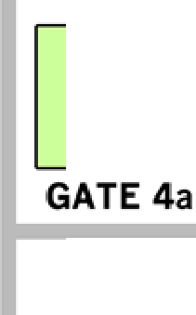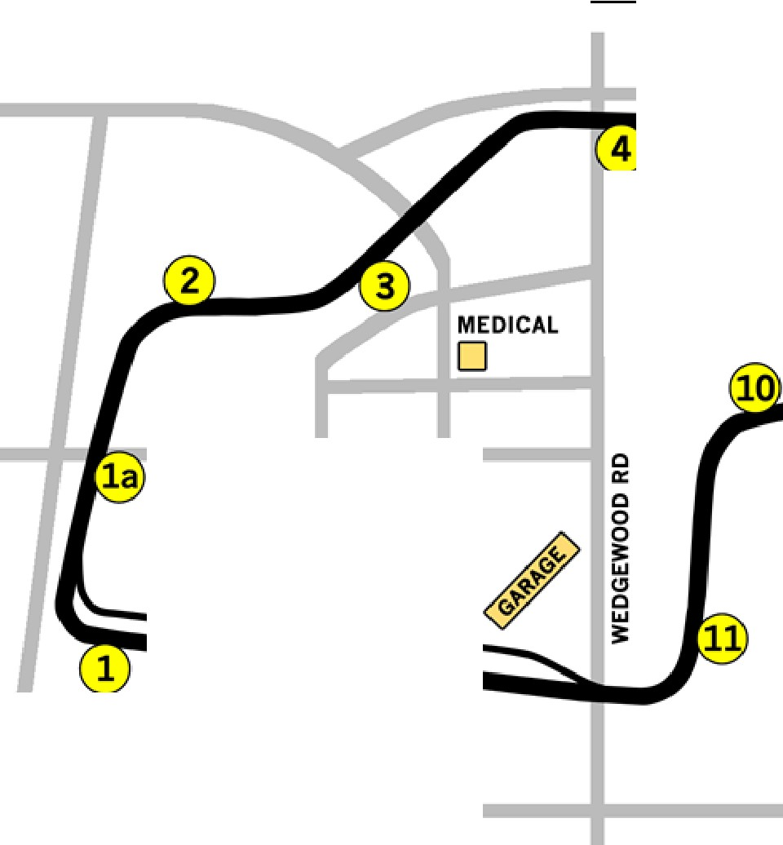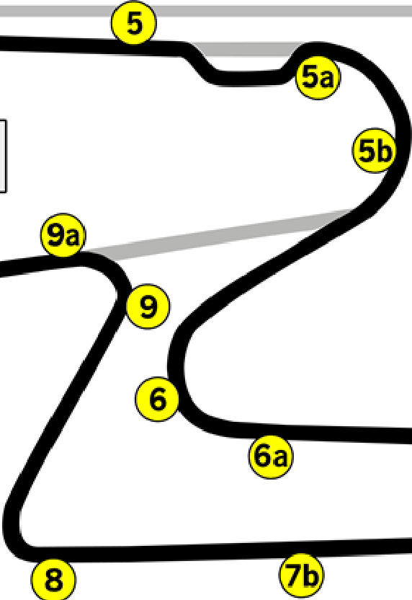

GATE 2

U)

.-I

® FLAG STATIONS

::, 0

1.­

a::

►

GATE 3

::, 0

0

1z.­

SOUTH

NORTH PADDOCK PADDOCK

7

Trailer Parking

for Reg.

*

BRONSON HILL RD

D

RE ISTRATION

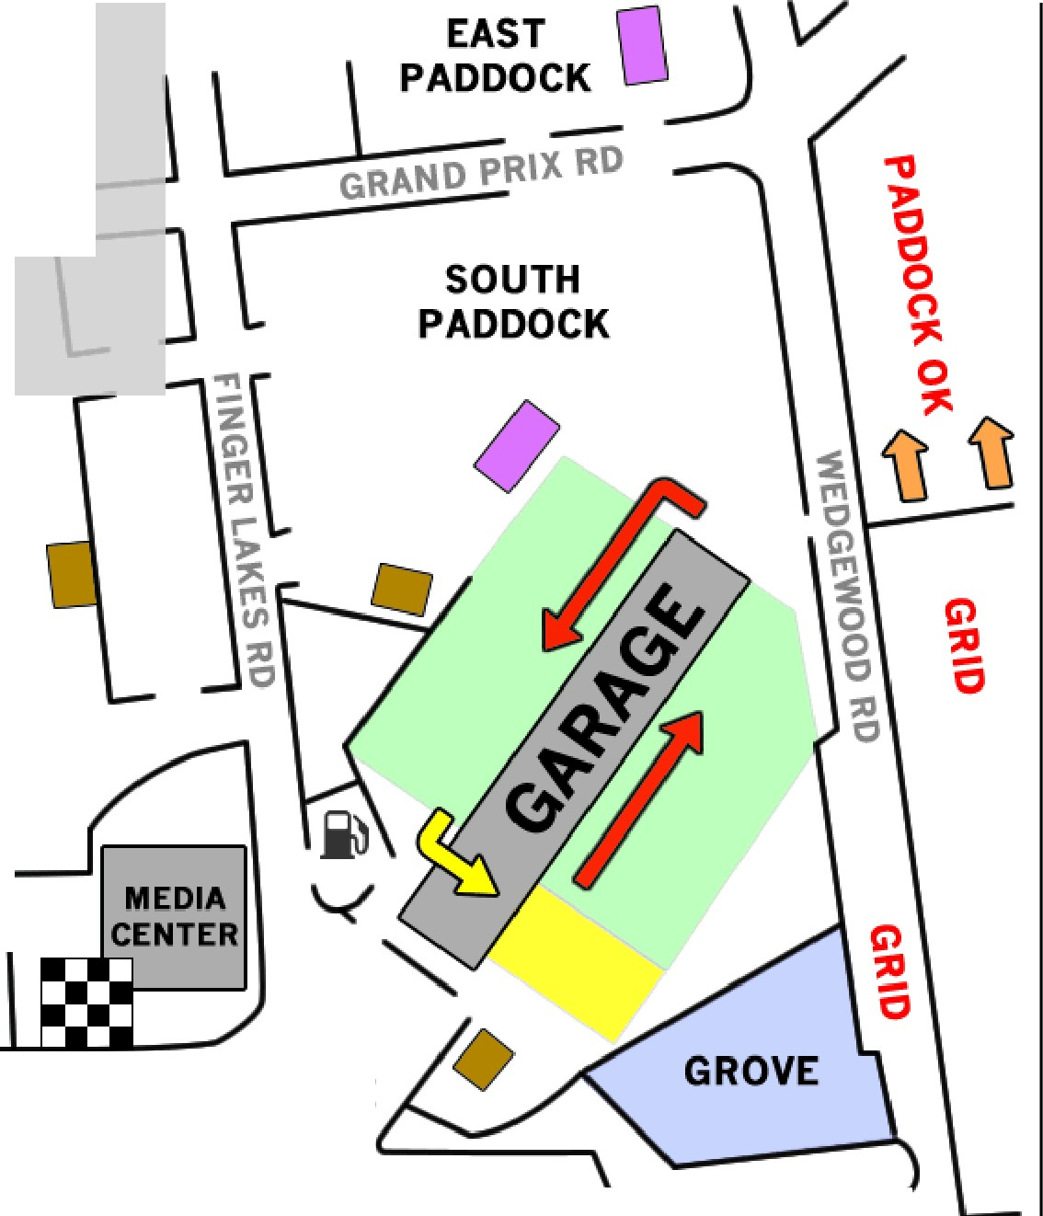

PIT TERRACE RV PIT ROAD RV

EASY

PIT TERRACE GRANDSTAND GATE

D BLACK FLAG

....,,,,

PIT ROAD